PERSONAL
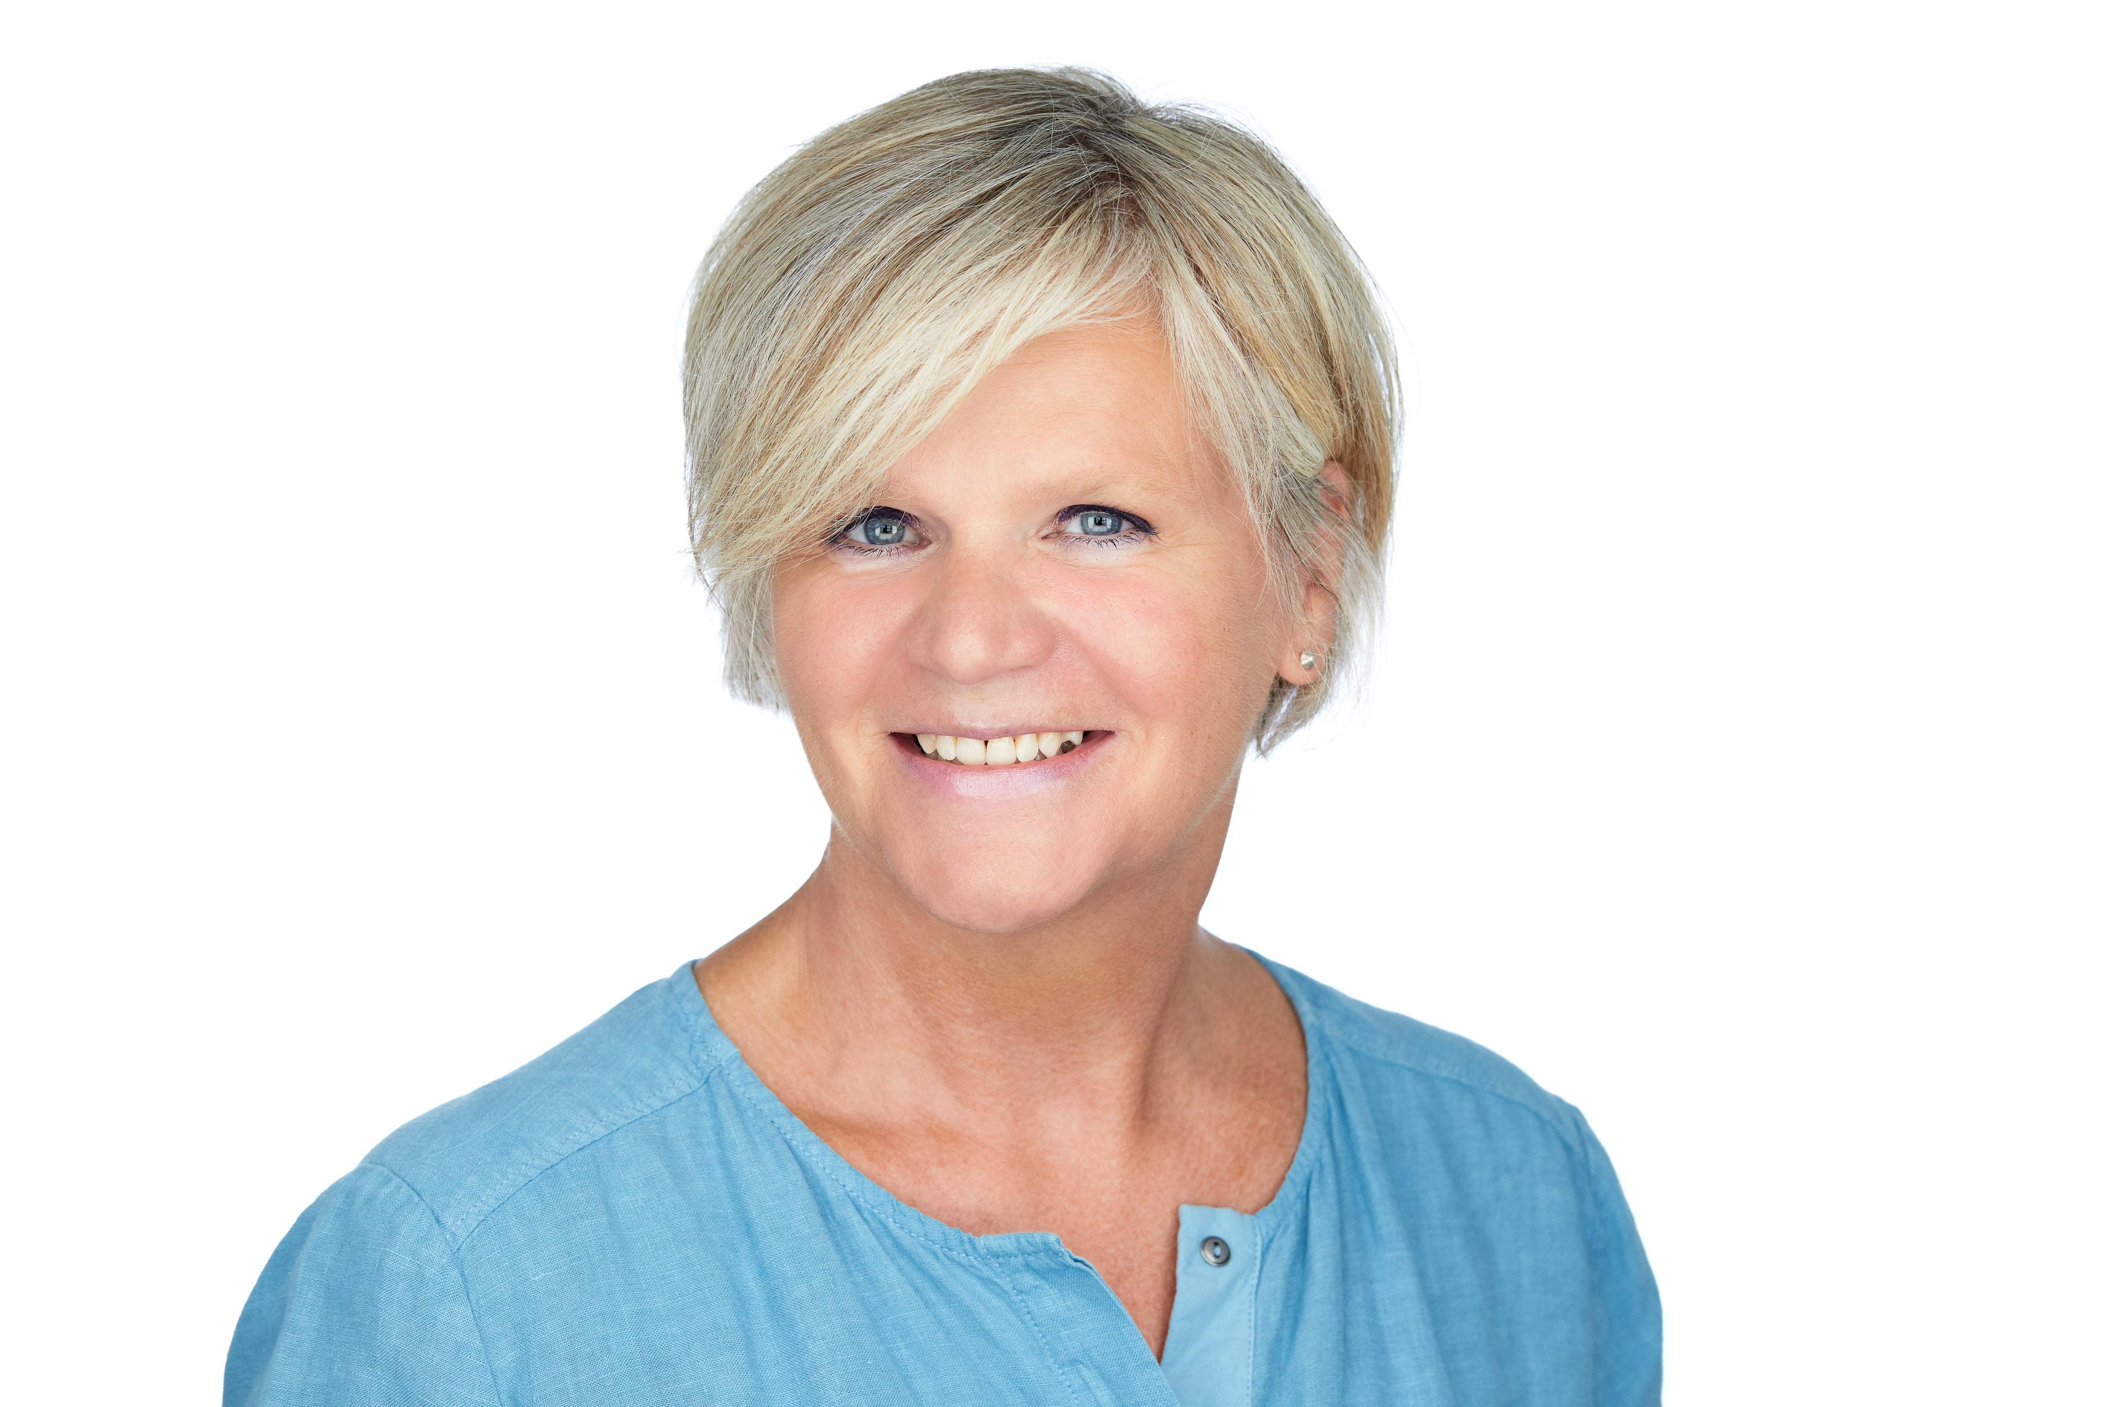

Date of birth 07 Dec 1964

Professional Profile
Executive Assistant with a proven track in assisting senior executives and teams in an international and fast-paced environment for more than 20 years. My key set of assets are an efficient, organized working style, excellent stakeholder management, attention to detail, excellent communication skills (at all levels of the organization) and a high quality support to leaders and multi-cultural teams across the globe. In addition, I have profound experience in organizing events on an international and local level with internal and external stakeholders.
Professional Experience
Pharmaceuticals International GmbH, /CH 01.2015 – 10.2018
Executive Assistant to GSCM (Global Supply Chain Management)
- Administrative support for Head of GSCM, SC Europe, GSC Logistics, GSC Specialty,
GSC TAPI
- Single point of contact, proactively coordinating daily agenda, defining priorities
in case of conflicts, set up of all meetings
- Supporting the yearly calendar planning
- Preparing meetings incl. logistics, providing relevant pre-reads, agenda, minutes,
consolidation of presentation, reports
- Planning event meetings for the Executive Committee
- Creating templates (e.g. agenda, organizational charts, travel requests procedure,
distribution and contact lists)
- HR support on/offboarding of new hires withing the team
- Administering organizational charts, vacation planner, Share Point and Intranet
- Close co-operation with all internal and external customers; reception of visitors

Novartis Animal Health Inc., Basel/CH 10.2012 – 01.2015
Executive Assistant to Global CFO
- Managed complex calendar and travel arrangements
- Responsible that all relevant documents are up to date and ready on time
- Event planning (conferences, anniversaries and global team events), incl. all logistics
- Supported purchasing dept. (created purchase orders, booked goods receipts) and
HR (On-/Off boarding process)
- Updated Finance Intranet Site
- Excellent co-operation at all levels (internally and externally), reception of visitors

Education, Trainings; LAnguage and IT skills
Further education and trainings include:
- Project Management, TÜV SÜD Akademie GmbH, Munich/DE, 2009 and edupool.ch, ZUG/CH, 2017
- Basics Business Administration, Rackow-Schulen, Hamburg/DE, 1994 and Dr. Ebert Akademie AG, Königswinter/DE, 2004-2005
- Stress management, time management, working in a team, career and self-marketing, SeminarCentre, Frankfurt/DE, 1999

Education:
- Commercial Certificate in HR, Grone Schule/Chamber of Commerce, Hamburg/DE, 1999
- Senior/Executive Assistant, Grone Schule, Hamburg/DE, 1996
- Foreign Language Correspondent (English/French), Inlingua Weltsprachen Institut, Hamburg/DE, 1981-1983

Language Skills:
- German native
- English fluent
- French basics

IT User Skills:
- Proficient user of MS Office (Word, Outlook, Excel, Power Point etc.)

