C U R R I C U L U M V I T A E

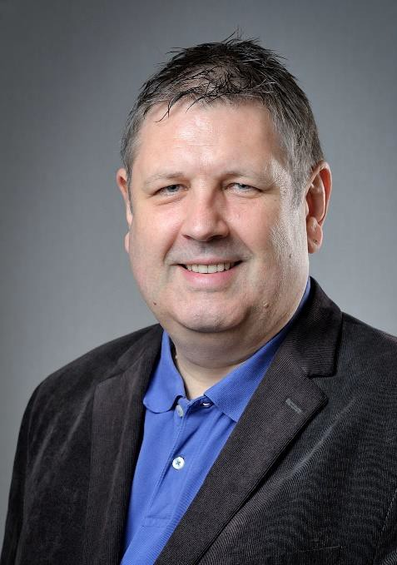

K EY C O M P E T E N C I E S

Regional head of technology and IP management with extensive expertise and experi- ence in leadership in an international company with a focus on:
- Development of products and components from functional demonstration to proto- types
- Continuous improvement of relevant technologies and development processes re- garding transparency, efficiency and speed
- Guidance of the project leaders within the portfolio management
- Interface with the “Business Development” division and support of the digital trans- formation of the company
- Constitution and care of networks (universities, research facilities and development partners)

E M P L O Y M E N T H I S T O R Y

1991-2018 Int Food & Beverage Packaging Germany
One of the world’s leading solution providers for the food and beverage industry within the field of carton packs and filling technology with approximately 5,000 employees in 40 countries.

Since 10/11 Regional head of technology and IP management
- Responsible for 14 employees, thereof 2 executives
- Budget responsibility for €6 million
- Direct report to the R&D director

Responsible for screening and scouting for technologies and their evaluation and in- troduction:

  - Reorientation of the technology division by means of:
    - Definition and implementation of a technology strategy
    - Alignment of the technology roadmap with the market organization
    - Centralization and structuring of cross-functional predevelopment
    - Interface management among the different departments and locations
    - Implementation of a technology radar and a maturity model
    - Implementation of a key-data system for technology evaluation and prioriti- zation
    - Early detection of technology trends and utilization of open innovation
  - Development of products and components from functional demonstration to prototypes
  - Support of the platform strategies in the departments
  - Continuous improvement of relevant technologies and development processes regarding transparency, efficiency and speed
  - Guidance of the project leaders within the portfolio management
  - Project lead, i.a.:
    - Implementation of a simulation system for prototype development
    - Design of a system to secure quality along the value chain
    - Predevelopment of flexibly shapeable aseptic carton packs made from pulp
  - Optimization of process times, e.g. during the production of opening systems, the sealing of packages or the package handling and conveyance
  - Interface to the “Business Development” division and support of the digital trans- formation of the company
  - Set-up and maintenance of networks (universities, research facilities and devel- opment partners)
  - Design and execution of in-house training courses for employees worldwide with a focus on the technology of the different packaging systems
  - Idea and knowledge management including the organization of idea contests and in-house project exhibitions
  - Analysis and monitoring of the competition
  - Internal auditing of departments according to DIN ISO 9000/1
  - Representation of the company in the appointments committee for an endowed professorship at the FH Hannover (University of Hannover), Germany

Achievements
  - Utilization of new technologies
  - Early inputs into the product development pipeline
  - Efficiency improvements through the introduction of platform and module ap- proaches
  - Development of new quality checks, e.g. of barrier properties

Responsible for the global IP management and the patent strategy
  - Reorientation of the patent department by means of:
    - Strategy change from a conservative to an offensive filing strategy
    - Internationalization of the patent department
    - Strict linking of the patent system to the innovation process via milestones
    - Implementation of patent conferences across locations
    - Implementation of a key-data system for the patent evaluation and prioriti- zation
    - Orientation of the IP filing activities towards the technology and product roadmap
    - Redefinition of the IP nationalization process to achieve more flexibility
    - Reduction of the number of idle IP rights
    - Implementation of a patent database
  - Analysis of the IP activities at the competition and in the industrial sector
  - Scanning of all ongoing projects for relevant topics and extension of the filing ac- tivities to predevelopments and technologies (“technology harvesting” in addi- tion to “invention harvesting”)
  - Revision of in-house developments and check for conflicts with third-party IP rights (FTO analysis)
Achievements
  - Tenfold increase of the cases filed yearly within five years combined with a corre- sponding increase of the company’s value through this enlarged patent portfolio
  - Efficiency increase of the patent department by focusing on the relevant IP rights according to the product roadmap

04/07 – 09/11 Department Head Technology lntelligence
  - Establishment of a development center in Dresden, Germany for the exclusive knowledge and technology transfer from the TU Dresden (University of Dresden)
  - Project lead for the development of a new machine architecture (rotary filler for carton packs) and inclusion of key customers

01/01 – 03/07 Department Head Future Technologies & Basic Research
  - Deputy project manager for the development of a new machine concept (rotary system)

07/99 – 12/00 Team Leader “New Machines”
  - Subproject manager for the development and market introduction of the current filling machine generation

12/91 – 06/99 Group Leader “New Machines”
  - Project manager for the introduction of CAD, including an EDM system with online link to SAP R/2 and R/3

E D U C A T I O N

10/79 – 11/85 RWTH Aachen, Aachen

10/79 – 12/85 Academic studies in mechanical engineering; branch of study: “fundamentals of me- chanical engineering“
Degree: Graduate Engineer

07/78 – 09/79 Military service, Lahnstein, Germany

1978 Neusprachliches Gymnasium Bergheim/Erft (secondary school) Leaving certificate: University-entrance diploma

P R O F E S S I O N A L T R A I N I N G

Permanent education in leadership topics (transformational leadership, situational leadership, building trust, etc.) and in presentation techniques, time management, auditing according to DIN ISO 9000/1

